Program 1:
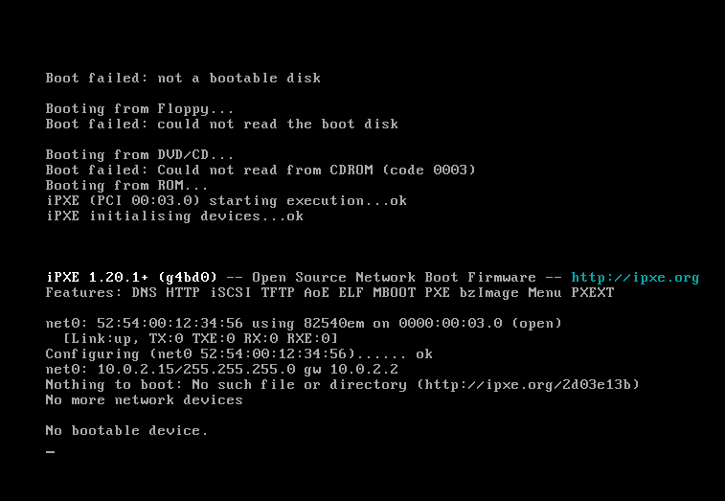

Program 2:
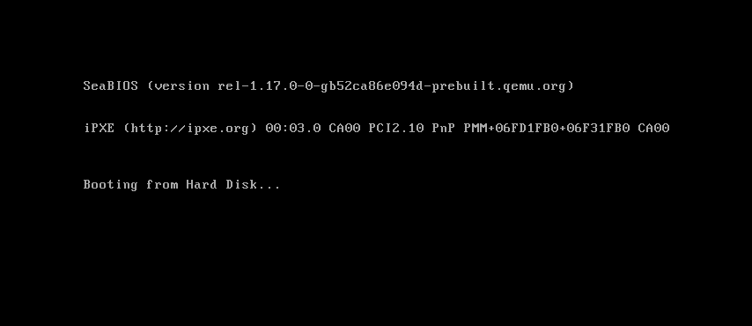
Commands run
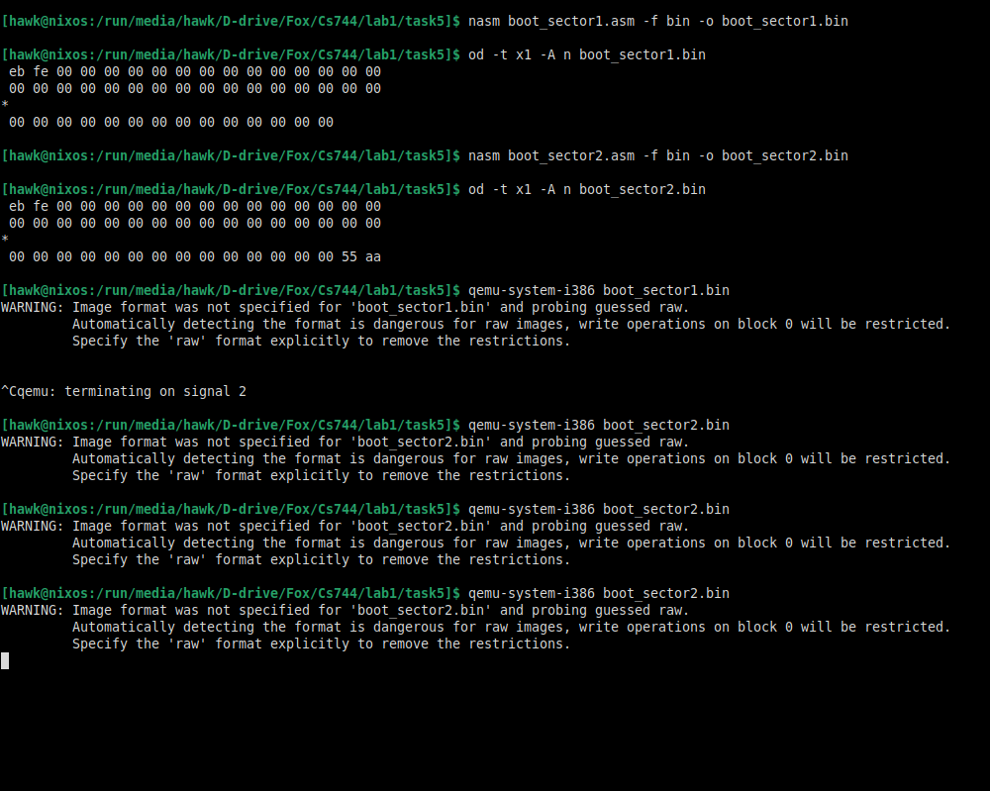
Ok so both have just a loop doing nothing.
However the first one doesn’t even have a driver defined so it fails.
The second has one so it just gets stuck in the loop.

